Test results

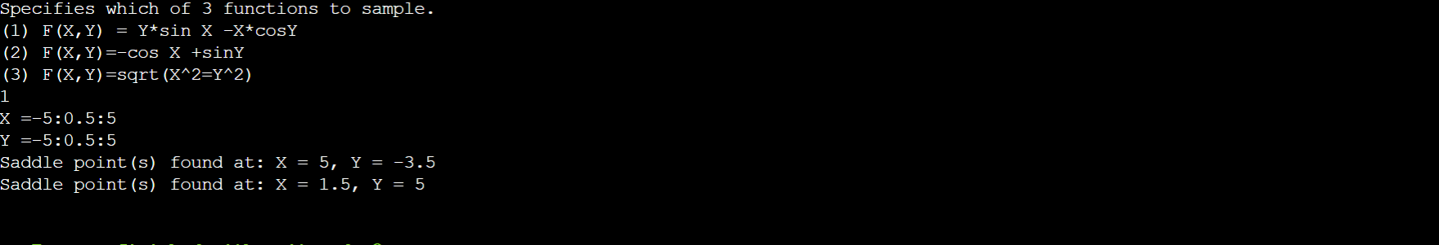

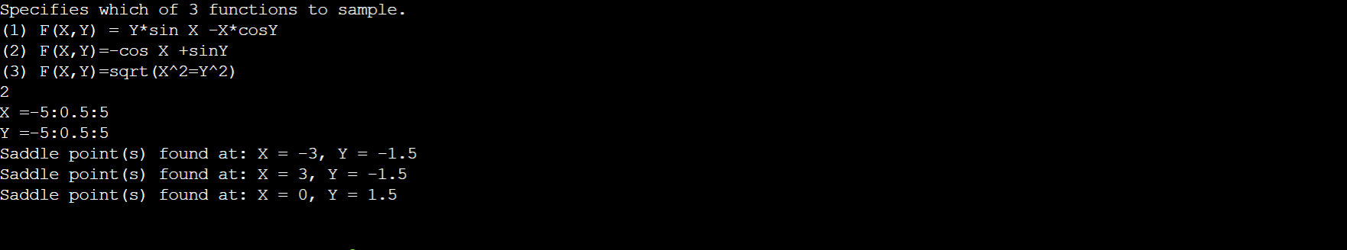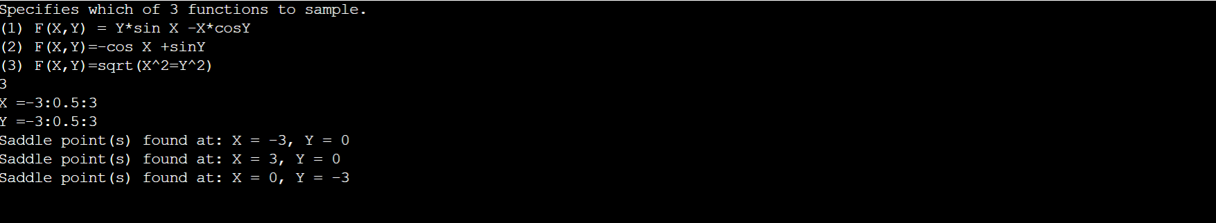

Answer to Questions

1. Challenges I encountered

I found it hard to generate a code since I'm not very familiar with C++, so I searched a lot of information in order to avoid making my code have syntax errors.

Also, I spent a lot of time on how to transfer the input into the int variable. By searching for a possible way on the internet, I finally found a way to split the ':' character among input strings and transform them into int and float numbers.

Secondly, I faced some problems when using class, local variables and global variables. In order to use those variables as I expected, I lastly declared them above all the program and combined some functions together.

Lastly, I spent lots of time on the function of finding saddle points. The for loops and conditions stuck me time by time, and since it was a scenario error, the compiler can't show the error to me, the only thing that I can do is to check my code again and again or ask for help.

In conclusion, this homework is really hard for me. I had been thinking about giving up during the process, but fortunately, I finished it, spending lots of time and effort.

1. What did I learn

I learned how to use "get line" to split the input, the structure of functions, and also learned the way of debugging. In order to find those scenario errors, I printed out each process and saw which part was incorrect step by step.

Also, I think I need to give a proper name to variables and write comments next time, since I sometimes would get confused with the variables' names too. Although it may take some time, and sometimes the whole program is wrong so I would have to delete them all, an easily readable program is helpful for avoiding scenario errors and making other people easier to read (in order to ask for help on debugging).